Dreamgrid

Open-Source Windows Opensimulator

Version 2.8

Copyright 2014 Outworldz, LLC

Contents

Starting up the System the First Time 1

**Setup Your Viewer:** 6

**Running the Grid manually** 7

**Links**: 8

Autobackup 8

Bird Module 10

**Security:** 13

**Bird Prims:** 13

**Network Traffic:** 13

**Statistics:** 13

**Links:** 15

Cache Deletion 16

Database Settings 16

**Robust Database:** 17

**Local Region Database:** 18

**Running MySQL as a Service** 18

**Starting Over with a Blank Database** 20

**Diva 'Wifi' Management Web Page** 22

**Wifi Admin account** 22

**Confirmation Required to Log In:** 23

**Splash Screen** 24

**Themes:** 24

**Friendly Name** 26

**Viewer Splash Screen URL:** 26

**SMTP Email** 27

**Default Avatars:** 27

Hypergrid and Domain Name Setup 29

Outworldz Shoutcast And Icecast Server 31

**Port Forwards:** 32

**Shoutcast Control Panel** 32

**Administering Shoutcast** 34

**WINAMP** 37

**MIXXX** 41

**Special instructions for MP3 files:** 42

**Setup Mixxx** 42

**Running Mixxx** 43

**Troubleshooting**: 46

Maps 46

Manual regeneration 47

Permissions 47

Physics Engine 49

Links: 50

Port Settings and UPnP 51

Publish Grid 58

Region Panel 59

Tips for regions: 59

Region Options 60

Overrides 61

Rules for INI files 62

File Folder Layout 63

Region Edit Panel 63

**Region Name Section** 64

**Advanced Section** 66

**Map Coords:** 66

**Region Port:** 66

**UUID**: 66

**Nonphysical Prim Max Size**: 66

**Physical Prim Max Size**: 66

**Clamp Prim Size**: 67

**Max Number of Prims in a Parcel:** 67

**Max Agents in a Region:** 67

**Region Specific Section** 67

**Permissions:** 68

**Physics Engine:** 70

None: 70

OpenDynamicsEngine 70

UBODE 70

**Maps:** 70

**Modules:** 71

Bird Module: 71

**Tides Enable:** 72

**Teleporter Enable** 72

Region Files 73

Refresh button 73

Add Regions 73

View menu 73

Moving Region Files from Older systems 75

Regions 76

Auto Restart and Startup Settings 78

Tides Module 82

Vivox Voice 85

License Agreement: 85

# Starting up the System the First Time

Download InstallDreamGridV4.exe from https://www.Outworldz.com and save it to a EMPTY folder. Make sure you only get it from [www.outworldz.com’s](http://www.outworldz.com's) secure web site.

Dreamgrid runs best on an SSD, but it can run on any HDD, or a mapped network Drive. It cannot run on a \\UNC formatted network drive.

Running the installer will download and unzip the latest Dreamgrid. You can also do this step manually by downloading the zip file from <https://www.outworldz.com/outworldz_installer/grid/> and manually extracting it to a blank folder.

Click Start.exe. After you click Start.exe, you may get a popup warning. All my code is digitally signed and is cryptographically verified to protect you and to assure you that the code you get is what is originally authored. It is virus-free and has no ads. It should say "Verified Publisher: Outworldz, LLC”.

**It may** **fail the Network Diagnostics**. For now, you can ignore such failures. Dreamgrid is designed to come up with a working grid, so let’s get you online first, then you can troubleshoot the Hypergrid Setup.

Now click [Start] in the top right of the menu:

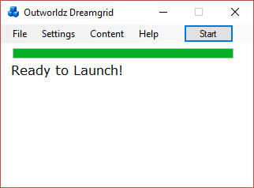

A DOS program "Robust" should launch.    This prompt will appear:

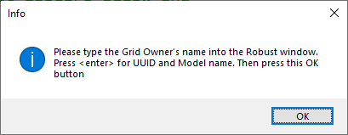

Please leave this screen open.

You need to create your "master user". This person will own the entire grid.   Go to the Robust DOS box and type the user name you want to own the grid at the command prompt as shown below:

[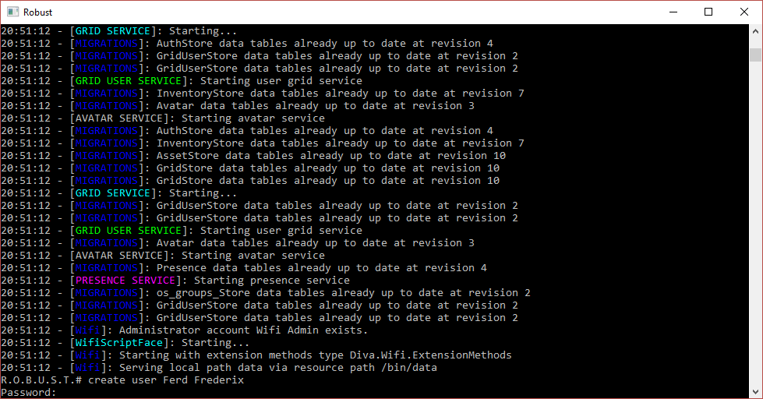](https://www.outworldz.com/Outworldz_Installer/Images/img7.gif)

Enter the owner of the grid's new Name and a password. Email is optional.  For other fields you can just press the Enter Key.   All the other questions can be safely answered with just the ENTER key.

[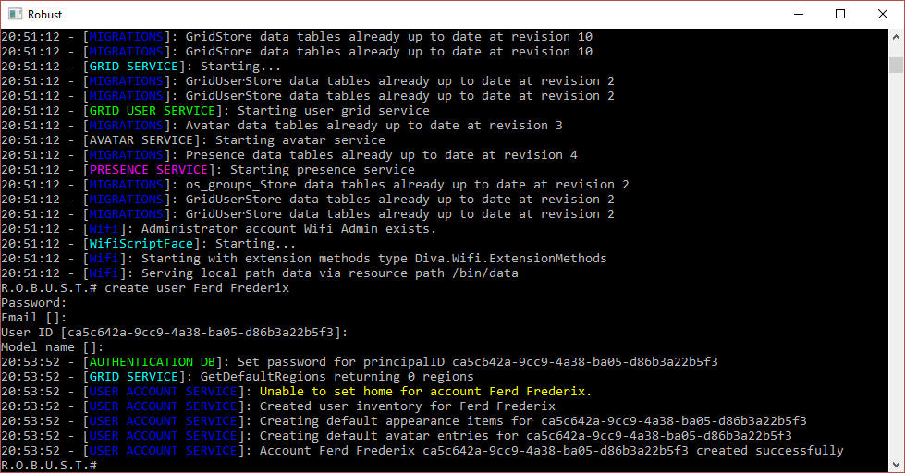](https://www.outworldz.com/Outworldz_Installer/Images/img20.jpg)

Now you can press OK to the screen prompt:



Another DOS box will appear. This will be your first region. It will be named "Welcome".  It will ask you for an estate name.  You can just press enter, or type in a new name.

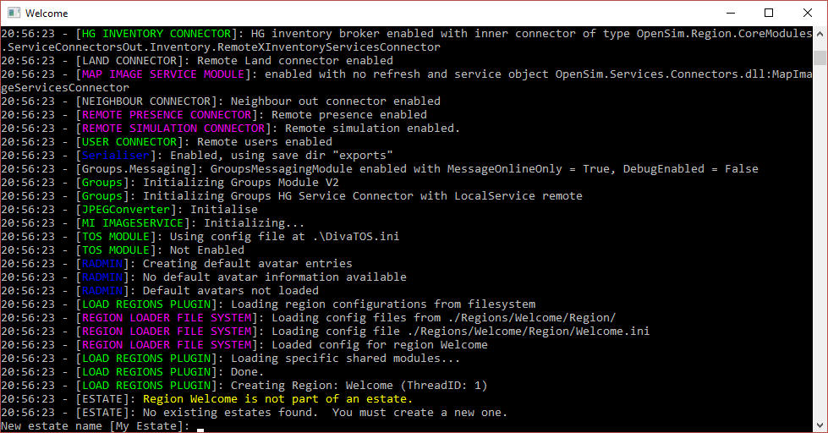

It will then ask you for the owner’s name of this region.   Use the same name that you first entered in Robust.

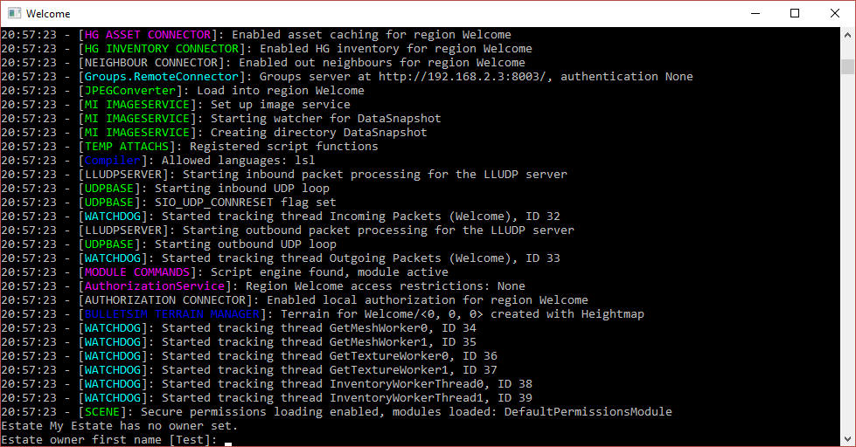

The system will eventually tell you "INITIALIZATION COMPLETE FOR Welcome - LOGINS ENABLED". You now have a working grid!

[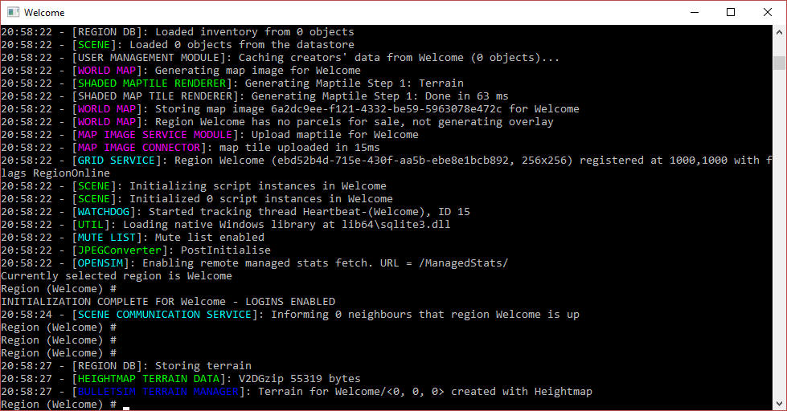](https://www.outworldz.com/Outworldz_Installer/Images/img1C.jpg)

## Grid Address

Click the first item in the Help menu - Show Hypergrid Address. It may print a name, or an IP address. This is your new grid address.

If it is an IP Address, your system will only run on your network. The Hypergrid will not be available until you work on the router. See the help section at the bottom of this article on Ports and Loopback.

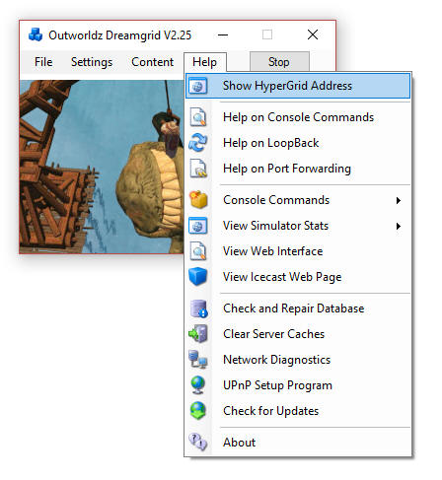

The system will print the address. Mine is shown below. Yours will be different, or an IP address.

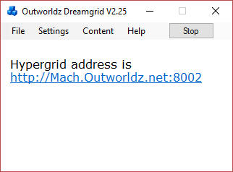

## Setup Your Viewer:

Download the Firestorm viewer for Opensim. You can get it from https://www.firestormviewer.org/.

Launch the viewer and go to the Viewer Preferences menu (Ctrl-P).

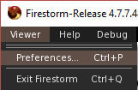

Go to the Opensim Grid manager screen:

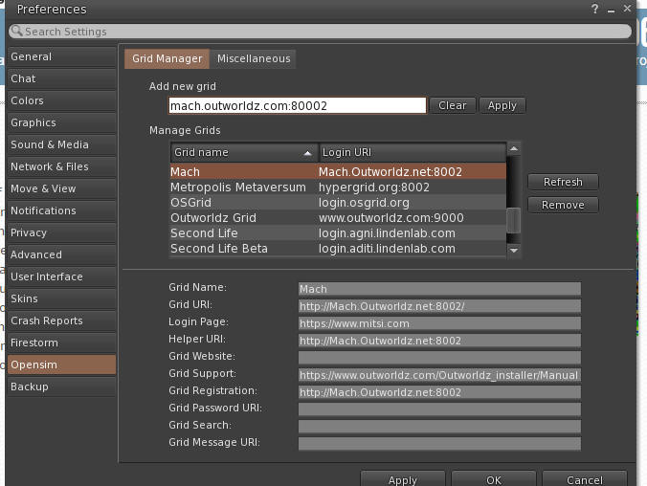

Add your new grid name to Firestorms "Add new Grid" field and click "Apply".

You should now be able to log in with the same First and Last Name and password you originally entered. You should then appear in an empty sim on a small round island.

If this does not work, please use the troubleshooting link at the bottom of this help file.

## Running the Grid manually

Once run once, you do not need Dreamgrid at all. The batch file **Start_by_command_line.bat** starts a command prompt with an instance of Opensim in it (an instance is a set of sims). The batch file launches Mysql, Robust and the Welcome region with the settings it needs for the INI files and the Log file.  
  
This is the batch file. You can use any part of it, such a “go regionname” to launch regions.

@remarkable batch file to start Dreamgrid manually.  
cd mysql\bin  
start startmanually.bat  
cd ..\..\opensim  
call runrobust.bat  
call go Welcome  
call go AnotherRegion

## Links:

Troubleshooting:

https://www.outworldz.com/Outworldz_installer/Manual_TroubleShooting.htm

Ports:

https://www.outworldz.com/Outworldz_installer/PortForwarding.htm

Loopback:

https://www.outworldz.com/Outworldz_installer/Loopback.htm



# Autobackup

If enabled, Autobackup module periodically saves all regions as OAR files.

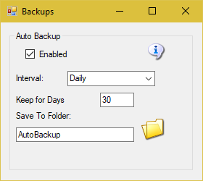

If this is enabled, Opensim will make an OAR backup of each region after Opensim has run for **Interval** time. The files will appear in the Outworldzfiles\Autobackup folder.

**Keep for Days** will delete any OAR older than this period of time.

**Save To Folder:** You can click on “Autobackup” folder name, or the folder Icon, and set a different location.

Links:

http://opensimulator.org/wiki/Load_Oar_0.9.0%2B

# Bird Module

The bird module makes flocks of birds possible.

You will need a bird. There is a button at the top of the Setup Page that will ask you for your Avatar Name and password. It will load a pair of Seagulls into your inventory.

You should log in and rez "SeaGull1" on the ground in one or more of your regions.



You will need to enable the bird module in each region's control panel.

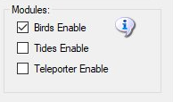

There are many settings for the Bird Module. You can use the defaults. You must also click Enable and reboot the grid. Birds must also be enabled in each Region. See each Region’s edit screen for the checkbox.

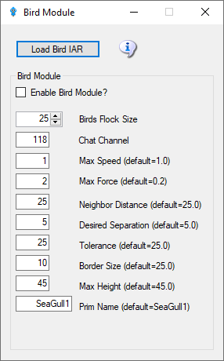

* + - Enable Bird Module: Determines whether the module does anything.
    - BirdsFlockSize = 50: The number of birds to flock
    - BirdsMaxFlockSize = 100: The maximum flock size that can be created (keeps things sane)
    - BirdsMaxSpeed = 3: How far each bird can travel per update. An update is 11 FPS
    - BirdsMaxForce = 0.25: The maximum acceleration allowed to the current velocity of the bird
    - BirdsNeighbourDistance = 25: Max distance for other birds to be considered in the same flock as others
    - BirdsTolerance = 5: How close to the edges of things can we get without being worried
    - BirdsBorderSize = 5:How close to the edge of a region can we get?
    - BirdsMaxHeight = 25:How high are we allowed to flock
    - BirdsUpdateEveryNFrames = 1: Update bird positions every N simulator frames
    - BirdsPrim = SeaGull1: By default the module will create a flock of plain wooden spheres, however this can be overridden to the name of an existing prim that needs to already exist in the scene - i.e. be rezzed in the region.

The following commands can be issued on the Console or via in-world chat or scripted chat on the Chat Channel to control the birds at runtime:

* birds-stop or /118 stop   
  stop all birds flocking
* birds-start or /118 start   
  start all birds flocking
* birds-enable or /118 enable   
  enable the flocking simulation if disabled and rez new birds
* birds-disable or /118 disable   
  stop all birds and remove them from the scene
* birds-prim <name> or /118 prim <name> changes the name of the bird prim that it loads
* framerate <num>   
  only update the flock positions every <num> frames, only really useful for photography and debugging bird behavior.

These commands are great for playing with the flock dynamics in real time:

* birds-size or /118 size   
  change the size of the flock
* birds-speed or /118 speed   
  change the maximum velocity each bird may achieve
* birds-force or /118 force   
  change the maximum force each bird may accelerate
* birds-distance or /118 distance   
  change the maximum distance that other birds are to be considered in the same flock as us
* birds-separation or /118 separation   
  sets how far away from other birds we would like to stay
* birds-tolerance or /118 tolerance   
  sets how close to the edges of things can we get without being worried. If distance is less than separation then the birds will never flock. The other way around and they will always eventually form one or more flocks.

## Security:

By default anyone can send commands to the module from within a script or via the in-world chat on the 'BirdsChatChannel' channel. You should use a high negative value for this channel if you want to allow script access, but not in-world chat.

## Bird Prims:

Any currently rezzed in-scene-object can be used as the bird prim. However fps is very much affected by the complexity of the entity to use. It is easier to throw a single prim (or sculpty) around the scene than it is to throw the constituent parts of a 200 linked prim dragon.

Tests show that <= 500 single prims can be flocked effectively - depending on system and network. However maybe <= 300 simple linksets can perform as well.

## Network Traffic:

I tested the amount of network traffic generated by bird updates. 20 birds (each with 4 linked prims) takes up about 300kbps in network position updates. 50 of the same birds generates about 750kbps traffic. Each bird uses roughly 15kbps of network traffic. This is all measured using an update framerate of 1, i.e. birds' position is updated every simulator frame.

## Statistics:

The stats command in-world or via script returns data to BirdsChatChannel. The console command returns stats to the console. All the modules parameters are returned including a list of the active bird prims currently rezzed in the region, and the UUIDs of those prims' root prim. Also included is a list of any avatar UUIDs that may be sitting on those prims.

Here is an example output:

birds-started = False

birds-enabled = True

birds-prim = SeaGull1

birds-framerate = 1

birds-maxsize = 100

birds-size = 20

birds-speed = 1.5

birds-force = 0.2

birds-distance = 25

birds-separation = 10

birds-tolerance = 5

birds-border = 5

birds-prim0 = OpenSimBirds0 : 01abef79-7fb2-4c8d-831e-62ce1ce878f1 :

birds-prim1 = OpenSimBirds1 : af85996d-af4d-4dda-bc89-721c51e09d0c :

birds-prim2 = OpenSimBirds2 : ca766390-1877-4b19-a29e-4590cf40aece :

birds-prim3 = OpenSimBirds3 : 6694bfa9-8e7f-4ac5-b336-ad13e5cfced2 :

birds-prim4 = OpenSimBirds4 : 1c6b152d-dcca-4fef-8979-b7ccc8139e1e :

birds-prim5 = OpenSimBirds5 : 08bba2cc-d427-4855-a7f0-57aa55109707 :

birds-prim6 = OpenSimBirds6 : bbeb8b6d-28d8-41a9-b8ce-dab3173bd454 :

birds-prim7 = OpenSimBirds7 : 45c73475-1f0f-487f-ac9f-87d30d0315e8 :

birds-prim8 = OpenSimBirds8 : d5891cc8-c196-4b05-82ef-3c7d0f703963 :

birds-prim9 = OpenSimBirds9 : 557b61e1-5fd6-4878-980e-e93cabcc078f :

birds-prim10 = OpenSimBirds10 : 7ff2c02d-d73c-4e49-a4e9-84b652dc70a9 :

birds-prim11 = OpenSimBirds11 : c2b0820c-ba20-4318-a0e8-ec6ad521f524 :

birds-prim12 = OpenSimBirds12 : e8e87309-7a47-4983-89a1-4bb11d05a40c :

birds-prim13 = OpenSimBirds13 : a351e0e3-ae99-48b8-877d-65156f437b33 :

birds-prim14 = OpenSimBirds14 : 150f1c3b-e9d9-4cda-9e03-69fb5286e436 :

birds-prim15 = OpenSimBirds15 : ebf63de1-d419-45d0-8eee-3db14295e401 :

birds-prim16 = OpenSimBirds16 : faad97af-4ee6-425c-b221-99ef53650e93 :

birds-prim17 = OpenSimBirds17 : d75ba544-bbc2-4f5a-9d7e-00e21ed6f191 :

birds-prim18 = OpenSimBirds18 : b91e42cb-ae5b-4f03-bf6e-dc03d52858b7 : a351e0e3-ae99-48b8-877d-65156f437b33

birds-prim19 = OpenSimBirds19 : 44aa3e14-56bc-43dd-afbd-7348c5dfe3a5 :

In the above example, there is one avatar sitting on bird-prim18. For more than one avatar the UUID list will be separated by spaces.

## Links:

<https://github.com/JakDaniels/OpenSimBirds>

# Cache Deletion

Opensimulator has many data caches to improve performance. You may optionally clear these caches. The system will refresh them on the next startup. This will slow your system down dramatically on the next boot as it must re-fetch all assets the next time it starts.

Opensim must be stopped to clear script and bake caches.

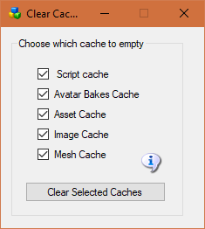

**Script cache:** Clearing the script cache is only necessary after an update to Opensim binaries. Dreamgrid will not delete the “.STATE” files so your virtual pets will not die.

**Avatar bakes cache:** this folder holds the various baked skin layers.

**Asset cache:**  holds the assets (mesh, prims, textures) and is typically very large. It automatically flushes itself every 48 hours.

**Image cache:** holds the images and is typically very large.

**Mesh cache:** is typically not used

# Database Settings

Did MySQL crash? See section **Crashes**.

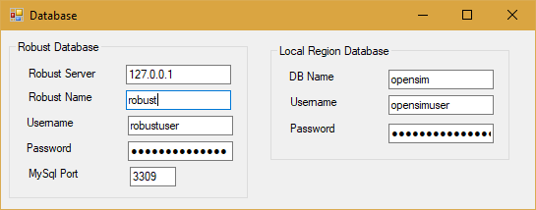

**Do not change any of these settings without knowing what you are doing!** Any change here must match complicated hand-made changes in MySQL! See the bottom of this help section for more details.

There are two databases in Dreamgrid: Robust is the login and inventory database. Each region also uses a separate Opensim database for storing what is in region.

Database root password is blank. This is safe as it only listens on localhost.

## Robust Database

* **Robust Server:** should always be 127.0.0.1. This is the Server that runs Robust (itself). It can be the IP address of a different server running MySQL.  
    
  Default: *127.0.0.1*
* **Robust name**: The name of the Robust database.   
    
  Default: *robust*
* **UserName:** The login name 'robustuser'@localhost'.   
    
  Default: *robustuser*
* **Password** : The password for Robust.

Default: *robustpassword*

* **MySQL Port:** The TCP/IP port that both databases use.   
    
  Default = 3309 to not interfere with the normal Mysql Port of 3306

## Local Region Database

* **DB name**: The name of the region database.   
    
  default: *opensim*
* **UserName:** The login name 'opensimuser'@localhost'.   
    
  default: *opensimuser*
* **Password** : The password for opensim region database.   
    
  default = *opensimpassword*

If you want to alter the username and password to either database, you must use the MySQL.exe program in a DOS box.

cd Outworldzfiles\mysql\bin  
mysql -u root  
use opensim;  
create user 'anewopensimuser'@'localhost' identified by 'opensimpassword';  
grant all on opensim.* to 'anewopensimuser'@'localhost';  
use robust;  
create user 'anewrobustuser'@'localhost' identified by 'robustpassword';  
grant all on robust.* to 'anewrobustuser'@'localhost';  
quit;

## Running MySQL as a Service

Dreamgrid will detect any running Mysql using the same port. You can install Mysql as a Windows service. There is a batch file *InstallAsAService.bat* in mysql\bin to set this up. Mysql will then start and stop safely with Windows. This batch file must be run once, as an Administrator. You type "CMD" in the search box, and then right click the Command Prompt and select "Run as Administrator".



Use that DOS box to run **InstallAsAService.bat**. Then type in 'Services.msc", and use it to start MySQL, or type in ‘net start Mysql’<enter>.

You can verify MySQL is running by typing 'mysql - u root<enter>'. If you get a mysql prompt, it is running as a service. Then type quit; with the semicolon, and enter.  
  
You should also set the service to restart so MySQL restarts on any crash. Windows knows about services and will send signals to MySQL to shut itself off gracefully. The only danger is that power fails and you corrupt the database. If you are serious about running a grid, then a UPS is a must.

**Crashes:**

Your MySQL database may be crashed. Here is a way to recover and start MYSQL manually.

Navigate to the **Outworldzfiles\mysql\bin** folder.

Then double-click "StartManually.bat”

Any error message it prints may be helpful. If the DOS window closes, a MySQL LOG file will be saved in OutworldzFiles\mysql\data as a *.err file. That may give you a clue as to what to do.

**My database still did not start!**

Try running

**Outworldzfiles\mysql\bin\Repair_ISAM.bat.**

Then double-click "StartManually.bat<enter>”. The DOS window that appears should ‘stick’ open.

Run Task manager by typing Ctrl-Shift-ESC.

Look for *mysqld.exe.* Wait for the CPU usage to go to 0 on mysqld.exe. This may take a long time as MySQL is rebuilding the database. It could take an hour or more, depending upon the size and your disk and CPU speed.

Now run CheckandRepair.bat by double clicking it.

If errors appear, answer any questions with a ‘Y’. This will take a long time as MySQL is repairing the database.

Once the Check and Repair is finished, type in ‘StopDatabase<enter>’ or double click it.

The DOS box that first appeared should now close. Your database has been recovered and it is safe to start Dreamgrid.

## Starting Over with a Blank Database

You can wipe ALL data out. If you do this, you must re-enter all accounts and recreate your system from OAR and IAR files. This WILL LOSE ALL DATA.

I recommend you make a backup of the Mysql\Data folder first.

I have not yet ‘lost’ a database, and I have seen dozens of them crash in oddball ways. Please contact me at [fred@outworldz.com](mailto:fred@outworldz.com) if you have questions or need more help in recovering a database. The largest was 70 Gigabytes which took four days just to get a copy sent to me. It was fixed in a few hours. The problem was to a single bad character in a UUID. So please don’t delete it unless you really, really want to start over!

If you MUST wipe out the database and start over, delete the folder Mysql\data. Then extract the contents of the file Blank-Mysql-Data-folder.zip to make a new Mysql\Data folder.

This will make it start over at the very beginning. The database should start up now. You must go to Robust, type create user<enter>’, and re-enter your Avatar name and password. You can then re-enter your estate information in each DOS box for Each region.

You can also restore the database if you have a .SQL backup. Or use OARs and IARs.

# Diva 'Wifi' Management Web Page

The Management Web page can be reached at <http://127.0.0.1:8002> if the checkbox is enabled and Robust is running.

For other users, it will be <http://YourDomainName:8002>, where YourDomainName is your Public, Internet-facing IP or DNS name.

The features of Wifi are:

* Account creation, optionally controlled by the administrator
* Configurable default avatars for new accounts
* Account updates by both users and administrator
* Account deletion by administrator
* Password recovery via email
* Simple user inventory management

You can change many of the parameters of Wifi in this panel:

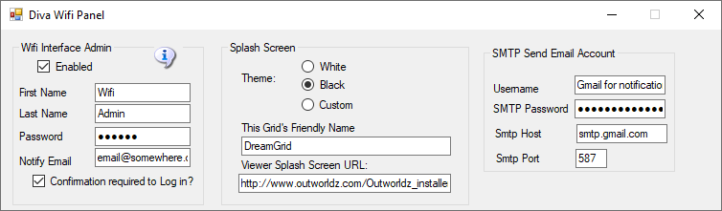

There are three sections that can be modified:

* Wifi Admin account: A super-user that administers the system
* Splash Screen: Things that affect the page that shows to new users
* SMPT Email: Settings to send email for things like password changes

## Wifi Admin account

The system automatically makes several accounts the first time it is booted. Once of these is "Wifi Admin'. This user has special rights in the web panel. It can administer all other accounts, delete them, and approve them.

A random password is chosen at startup. You may change it. Since the Hypergrid exposes this login page to the Internet, please choose a strong password.

You must have a user with levels set to 200 or higher in order to change the name from Wifi Admin. You can add another user and set it, too.



### Confirmation Required to Log In:

Wifi can create new accounts in two manners: uncontrolled and controlled. If you choose to have controlled account creation, every time someone creates an account, the Wifi Admin account will receive an email notifying of such an event (make sure you have the Wifi Admin’s email address properly set).

You should then login to Wifi as administrator, and choose USER MANAGEMENT. You will be presented with a list of all pending accounts, which you can then approve or delete. If you choose to have uncontrolled account creation, then anyone can create an account in your world without going through your approval.

## Splash Screen

### Themes:

There are three possible theme colors, Black on White, White on Black, and Custom. The default theme is Black, or the selected theme will be copied by Dreamgrid into the real WifiPages folder on startup.

#### Customizing your theme

You can change the theme with this switch to one of several sets of folders:

White theme consists of two folders:

Outworldzfiles\Opensim\WifiPages-White

Outworldzfiles\Opensim\bin\WifiPages-White

Black theme consists of two folders:

Outworldzfiles\Opensim\WifiPages-Black

Outworldzfiles\Opensim\bin\WifiPages-Black

If you want to make modifications, please use a custom theme. Otherwise your changes to the -Black, -White or WifiPages folders will get written over in an update.

First copy both the two Black or the two White folders to the WifiPages-Custom folder next to them. Each set of files goes in these places:

* Opensim/WifiPages-Custom
* Opensim/bin/WifiPages-Custom

The updater will never overwrite these custom pages. If you make changes to the custom pages, they will be set into the Wifi page on startup.



#### Changing the HTML

Diva Canto uses some advanced, Opensim-specific code in her Diva pages.

The site starts from Opensim\bin\WifiPages\index.html.

**#includes** There are several include directives that bring in the rest of the web site. Diva uses a series of <!--#include file=header.html --> statements to bring in files from the other folder set in Opensim\WifiPages. Includes in those files then bring in more and more of the web pages from Opensim\Bin\Wifipages.

**#get** There are several statements that are replaced by server data:

**Users in World:** <!-- #get var=UsersInworld -->

**Regions:** <!-- #get var=RegionsTotal -->

**Total Users:** <!-- #get var=UsersTotal -->

**Active Users last** <!-- #get var=UsersActivePeriod --> **days**

**Active Users:** <!-- #get var=UsersActive -->

**Everyone wants to change the image:**

For the **BLACK** theme, do the following:

Copy the folder \OutworldzFiles\Opensim\bin\**WifiPages-Black** to \OutworldzFiles\Opensim\bin\**WifiPages-Custom**  
Copy the folder \OutworldzFiles\Opensim\**WifiPages-Black** to \OutworldzFiles\Opensim\**WifiPages-Custom**

Save the image as a JPG file in \OutworldzFiles\Opensim\bin\**WifiPages-Custom**\images\**orange-planets-background.jpg**

Go to Settings->Web Control Panel. Click the box and change it from **Black** to **Custom**.   This will copy the files from **-Custom** to the working folder, bin/WifiPages.

Navigate to <http://127.0.0.1:8002>.  You should see your new image.

For the **WHITE** theme, do the following:

The new image goes in \bin\**WifiPages-Custom**\images\**header.png.** You must first make the folder

Copy the folder \OutworldzFiles\Opensim\bin\**WifiPages-White** to \OutworldzFiles\Opensim\bin\**WifiPages-Custom**  
Copy the folder \OutworldzFiles\Opensim\**WifiPages-White** to \OutworldzFiles\Opensim\**WifiPages-Custom**

Then click the Theme setting for **White**. This will copy the files from custom to the WifiPages folder.

Navigate to <http://127.0.0.1:8002>.  You should see your new image.

### Friendly Name

The friendly name appears on the login screen at the top. It is broadcast to viewers as the grid name in the grid Selector Pulldown. If you change this, you must delete and re-add the grid to the viewer.



### Viewer Splash Screen URL:

The Splash screen URL appears on the login screen as a web page. You can use any web page. If you change this URL, you must delete the grid setting in your viewer, and re-add it to get it updated.

If you change this, you must delete and re-add the grid to the viewer.

The Splash Screen URL is underlined in Red:



It is recommended to set this to http://(URL of your grid):8002 so they can see the Diva Login Page.

## SMTP Email

You may optionally set up Simple Mail Transport Protocol to send email for events such as password changes.



If you use Gmail for SMTP, you will need to enable Less-Secure mail settings at Gmail in your account.

You can find information about this at <https://support.google.com/accounts/answer/6010255>

## Default Avatars:

A “Wifi.ini” file lets you select one of three default appearances for newly created avatar. But in a new environment you must set those avatars up first.

1. Create the avatars with names “Female Avatar”, Male Avatar”, “Neutral Avatar”. and authorize them via the Wifi Admin.
2. Login as each avatar in turn. They will usually appear as a cloud initially and then after a short while rez to appear as “Ruth” wearing four basic body parts, new pants and new shirt. These parts come directly from the Opensim Library and ***MUST NOT*** be worn in your final appearance for the default avatars. You can COPY these library parts into the avatar’s inventory if you wish, or create new body parts and clothing, but before you finish you should remove any items that show as “worn” in the Opensim Library as those will not rez on avatars based on these models.
3. Create new body parts and clothing and edit them and/or add any other mesh, clothing, attachments or HUDs you wish to appear on the avatars.
4. Note you can extend (or change the avatars names or labels) for the default appearances and/or change the preselected default by altering Wifi.ini.

;;Syntax: AvatarAccount_<AvatarType> = "<FirstName> <LastName>"  
;;(replace spaces in <AvatarType> with underscore)  
AvatarAccount_Female="Female Avatar"   
AvatarAccount_Male="Male Avatar"   
AvatarAccount_Neutral="Neutral Avatar"

;; Preselection for default avatar in new account registration   
AvatarPreselection="Neutral"

1. When you create a new avatar via the Wifi web interface based on these predefined avatars the items worn will appear in the newly create avatar’s inventory under Clothes -> Default Avatar <AvatarType>.

# Hypergrid and Domain Name Setup

Hypergrid requires a DNS name or a Public IP be entered here. You can register your own domain, or use your routers public IP, or use the Outworldz system’s’ free Dynamic DNS system (DYN DNS).

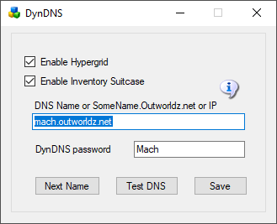

**DNS name:** For a Free Dynamic DNS name, use "somename.outworldz.net". Choose a simple name and add ".outworldz.net". For domain names, the letters and numbers a-z and 0-9 and a dash (-) are the only allowed characters.

Do not add anything else other than a name and .outworldz.net.

IP addresses may be used. If blank, the PC's LAN address will be used. Hypergrid will not be available, but otherLAN PC's will be able to connect. This is ideal for schools and other types of private work grids.

When there is no network connection, such as when travelling, use localhost, or 127.0.0.1. Both of these allow only the viewer on the server to connect.

**DynDNS Password**: This is a random number that may be used to keep your DNS Name from being used by others. It's first come, first-served. Your password must be copied from one installation to another to use the same DYN DNS name. If you need help with this, or wish to delete your DNS name, please email me at [fred@outworldz.net](mailto:fred@outworldz.net).

**Enable Hypergrid**: If unchecked, the Hypergrid will not be available. The grid will be only a Private Grid, with access possible only by logging into the grid directly.

**Enable My Suitcase**: If checked, Hypergrid travel uses a viewer suitcase. The purpose of the Suitcase is to prevent a foreign "rogue" grid from stealing your inventory while you are visiting. However, any items in your suitcase are exposed to other grids. you can only rez or give items in other grids that are already in your suitcase.

The My Suitcase folder is special: it is the folder tree that receives objects you collect while you are visiting other grids. But now it is even more special: it is the **only** folder tree that is accessible to you (and therefore to the rest of the Internet) while you are traveling. Period.

If you disable the suitcase by unchecking this box, as OsGrid does, you will be able to rez and give items while on other grids from anywhere in your inventory. Items you take or are given will still end up in your suitcase.

**Next Name**: to use the free Outworldz Dynamic DNS, click "Next Name" to get a name. The Dreamgrid Dynamic DNS system will automatically register your PC's ever-changing IP address and keep your sim running.

**Test DNS**: Will register the DNS name and check that it is resolvable. The result should be the Public IP address of your router.

links:

<http://www.canyouseeme.org>

<http://www.outworldz.net>

# Outworldz Shoutcast And Icecast Server

Outworldz Dreamgrid contain a free Icecast and Shoutcast server. You can use this to broadcast voice and music to any radio, web page, Opensim, Second Life, or your own grid.

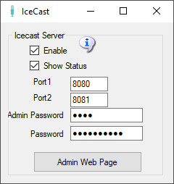

* **Enable**: Starts a Icecast Server when Start is clicked.
* **Show Status**: Displays in the window the servers status
* **Port1 & Port 2**: Default is 8080 and 8081. Both ports must be Port Forwarded in your router from the Internet so users can hear the music.
* **Admin Password**: Enter a strong password for control of your Shoutcast server. This Password protects a web page, so choose a good one.
* **Password**: This password is used to stream music to your server. You give it and the stream mount point out to applications and musicians who can stream music using your server.
* **Admin Web Page**: Click this button when Icecast is running to get to the control panel web page.

**How to Broadcast Music:**

To streaming your own radio, you need a program to play music and send it to your stream.

I use Winamp. You can also use Mixxx, or any third party streamer. Instructions for both follow.

### Troubleshooting IceCast:

If it cannot connect, make sure Icecast is running in a separate DOS box.

You do not have to run the grid to stream music. It is only used to set up the files and start Icecast. For example, you can run a radio station or use it for Second Life. There is a batch file in /Icecast called 'icecast.bat' that will run the server.

## Port Forwards

Add port 8080 and 8081, (or any other port pair > 1024 ) to your routers Port Forward list.  You should also check they are not blocked by your firewall or anti-virus. This is my setup:

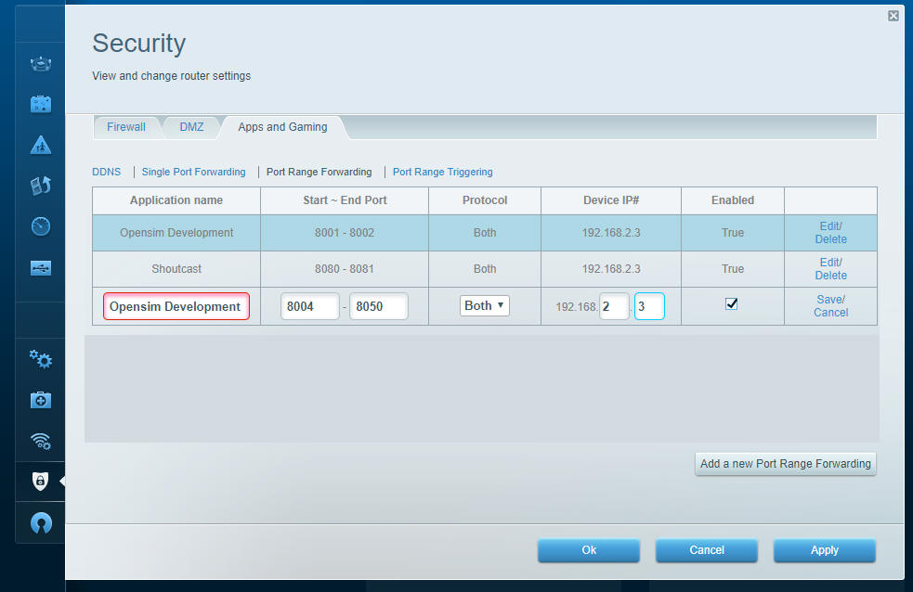

The Shoutcast setting shown above is used when you are running the Icecast/Shoutcast server.

## Shoutcast Control Panel

Click the Shoutcast [Control, View and Listen] Button to view your Shoutcast web page.  

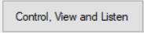  
  
It should open a web page that looks like this when there is no stream playing.  
  
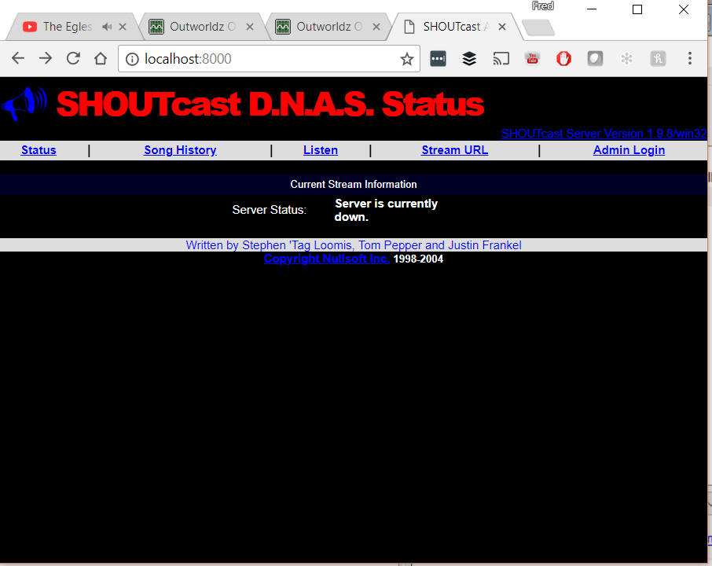  
  
  
Go find some music in Winamp and press "Play".  
  
The screen should now change to show it is up  
  
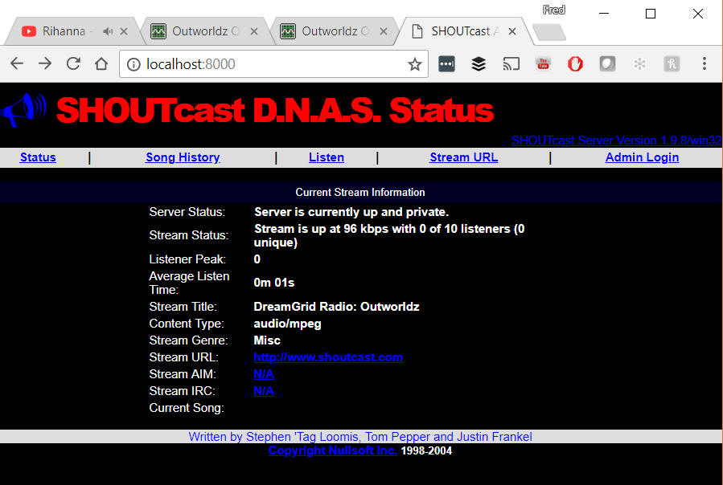

**Administering** Shoutcast

Clicking the Admin Login button at the upper right will require a password.  

The userid is "admin".

Enter the Admin Password you created when you set up Shoutcast in the DreamGrid.  
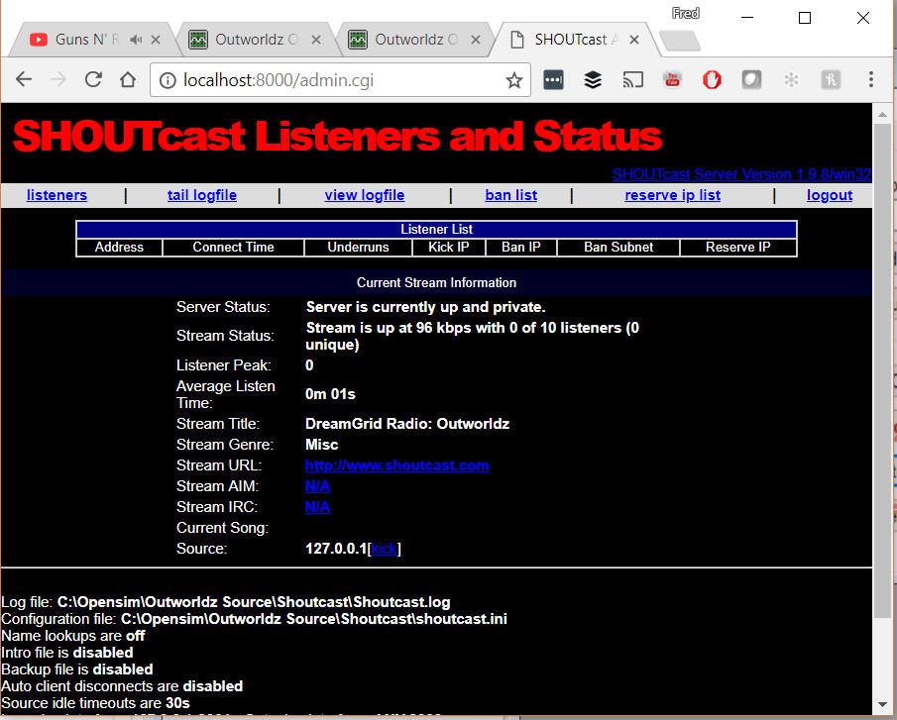  
  
You can administer ban lists, view logs, and do other maintenance tasks here.

### Setting up your In-world radio

You can use any radio script to set your radio onto the land. An easy way is to navigate to the About Land tab and enter the URL into the Sound Tab. For more information see

http://wiki.phoenixviewer.com/land_audio_tab  
  
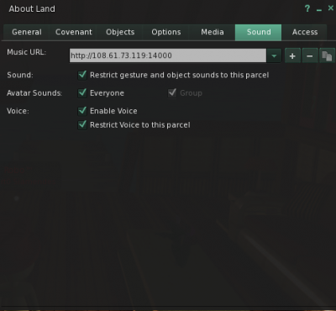  
  
Now enable the media to play in your viewers Sound & Media tab.  
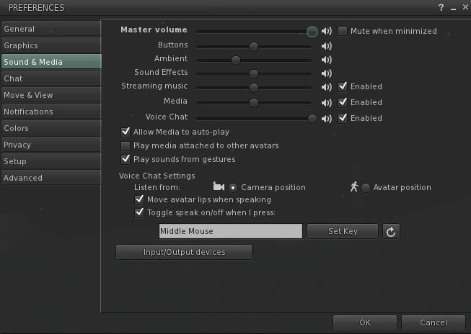  
  
For more details, please see <http://wiki.phoenixviewer.com/land_audio_tab>

## WINAMP

You can use many different music or microphone players to stream music to your system. These instructions are for the popular Winamp player.

First, download and install Winamp from

https://www.outworldz.com/Outworldz_installer/Grid/winamp5666_full_en-us_redux.exe

Then download and install the Shoutcast DSP from https://www.outworldz.com/Outworldz_installer/Grid/shoutcast-dsp-2-3-5-windows.exe

Run Winamp.  You should see a screen like this:

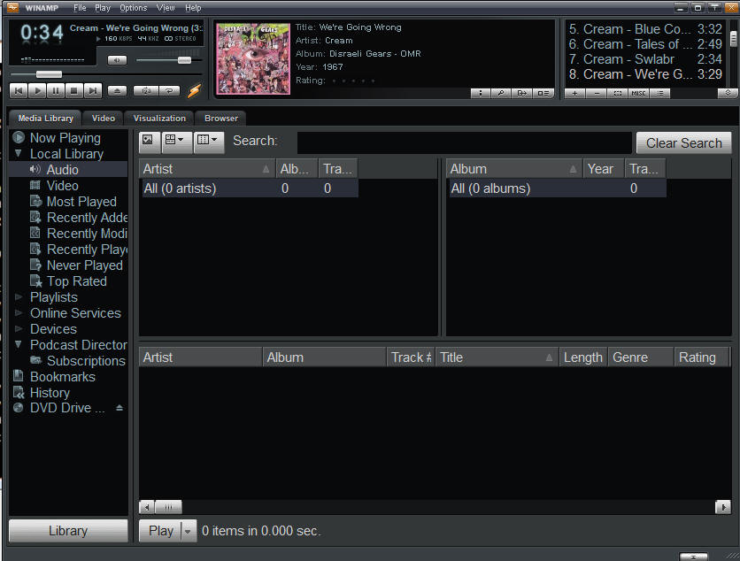

Navigate to the Options -> Preferences screen

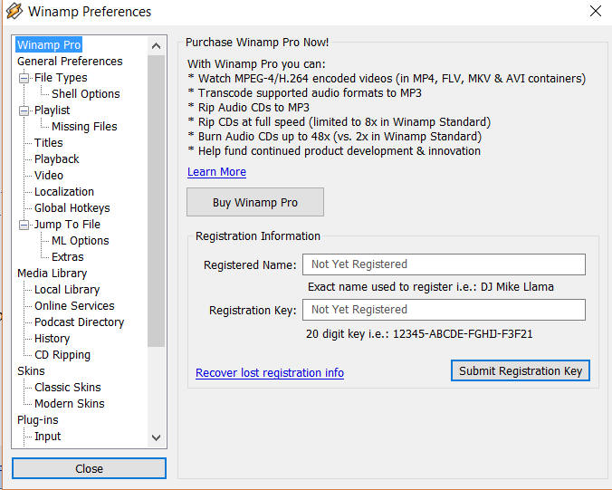

Scroll to the DSP/Effect section on the left side:

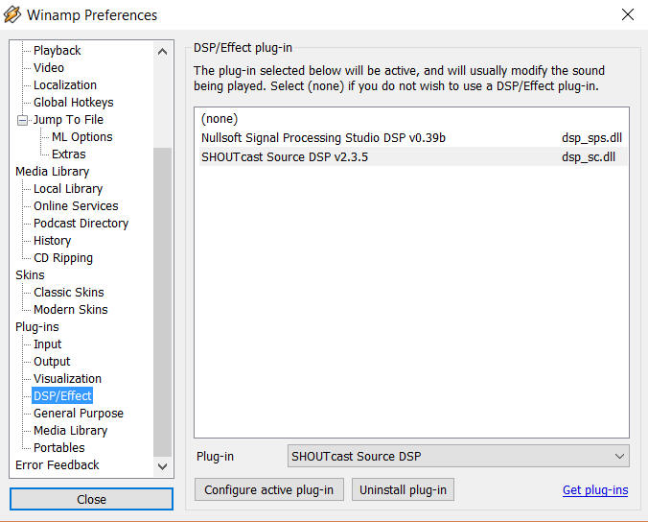

Double click the Shoutcast DSP on the right side to get the DSP setup screen.

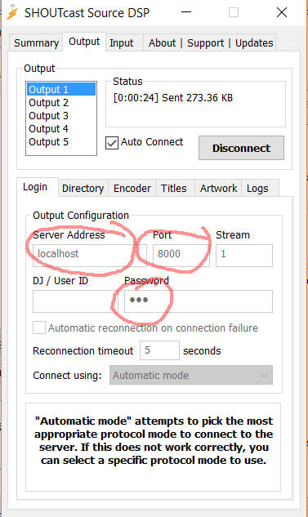

**Server Address**: Enter 'localhost' for the Server Address.  If you wish to run Winamp on a different machine, use the Server LAN address.

**Password:** Choose the same password as you used in the Dreamgrid's password field (not the Admin password).

**Port:**Also enter the same port you used in the Dreamgrid setup screen.  The default is 8000.   If you want others to hear this stream from outside your network, remember to either forward the port or enable the UPNP setting and restart your server.

You can configure more of the screens, but they are not required.

Click **[Auto Connect]** and make certain you see it connect to your Shoutcast server.

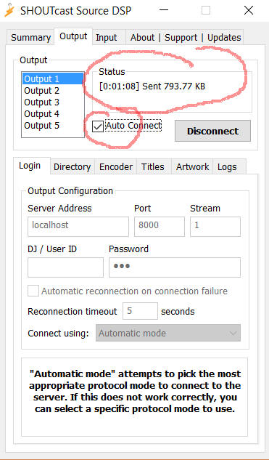

## MIXXX

Download and install [Mixxx](https://www.mixxx.org/) from https://www.mixxx.org/. This is what the screen looks like.

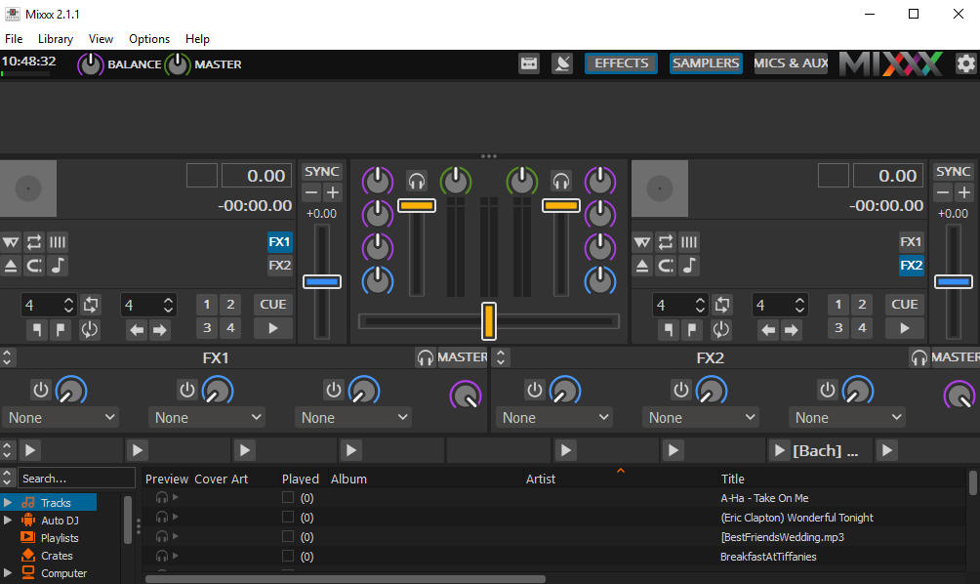

### Special instructions for MP3 files:

To enable MP3 streaming on Windows, you must follow these instructions:

First, download the lame library from http://www.rarewares.org. The download page includes 32-bit and 64-bit versions. Make sure the version you download matches the version of Mixxx that you use, not the version of Windows. If you are on 64-bit Windows but are using 32bit Mixxx, you need the 32bit (“x86”) version of the library. Unpack the downloaded ZIP archive.

Copy libmp3lame.dll to the location you have installed Mixxx, probably C:\Program Files\Mixxx\.

### Setup Mixxx

Go to the Mixxx Preferences Screen, then select the "Live Broadcasting" tab on the left. These are the settings I used:

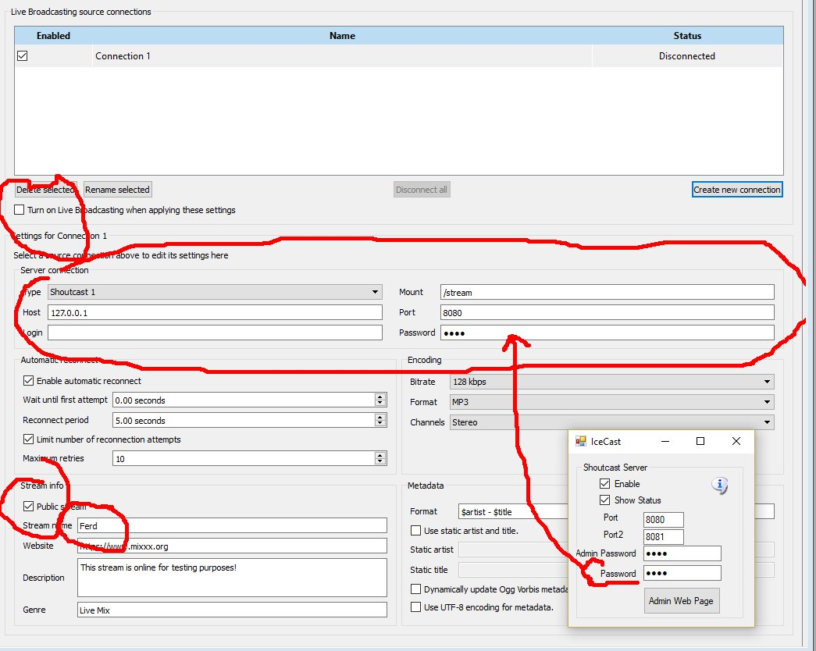

* Check **Turn On Live Broadcasting**
* Set type to **Shoutcast1**
* The standard mount point everyone uses is **/stream**
* Host is **127.0.0.1**
* Port is **8080** from the Dreamworld setup.
* Login is **blank**
* Password is the same password  from the Dreamworld setup.
* Check **Public** if you want your stream to be on the Mixxx website. Give it a name.
* Click **Okay** and the screen will gray out and should show no errors.

### Running Mixxx

On the top of the Mixxx main screen is an **Options** menu. Click **Enable Live Broadcasting**. I have it shown in the photo. Load a track and click play. For me, that was hard to find! It is circled in the picture, and shows a pause button.

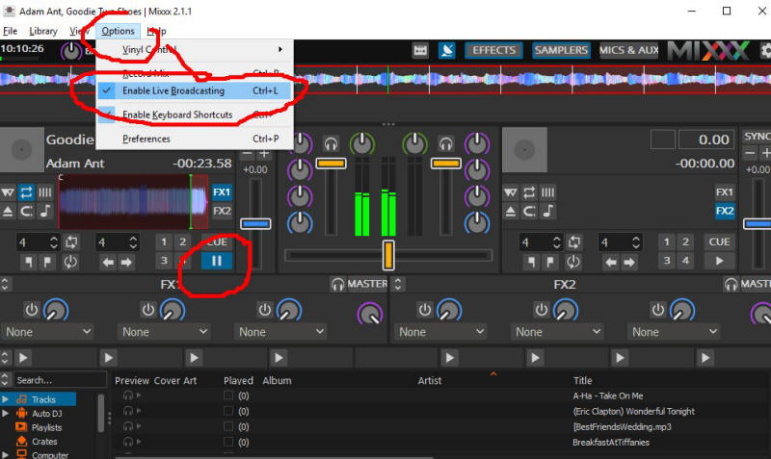

Use a web browser and navigate to http://127.0.0.1:8080/stream and click the play button. You an also click the **Admin Web Page** button. You should hear the music, delayed by maybe 15 seconds. This is normal buffering. Click Stop in Mixxx and the music will play for a bit longer due to the buffering.

The Public URL or Domain Name for your world is entered into your sim instead of 127.0.0.1, so for my simulator, the music URL becomes **http://www.outworldz.com:8080/stream**. This URL must include the 'mount point' of /stream you entered earlier.

Navigate to http://127.0.0.1:8080. You should see the standard web page for Icecast. Yours truly, can log in using your administrator password, see the status, and see the mount point.

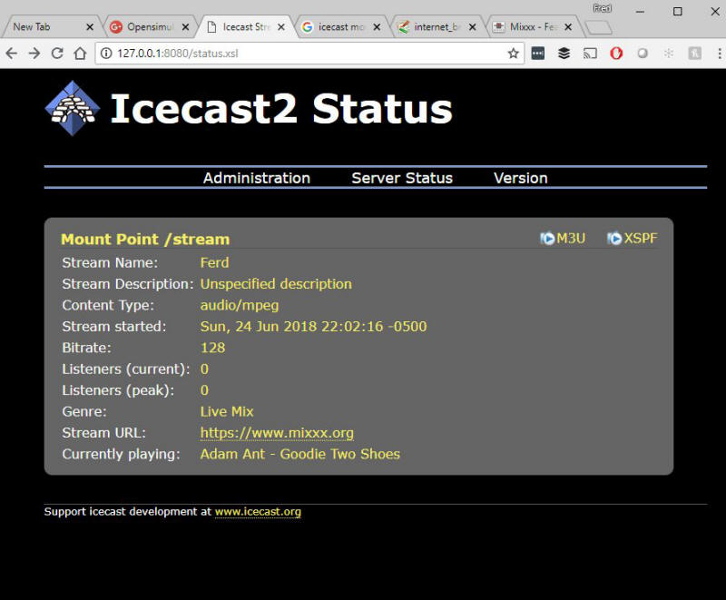

# Maps

Opensim has many different maps settings. Dreamgrid has 4 easy-to-use combinations. Opensimulator also has several Map tile makers. It can take a very long time to boot when using the Good, Better and Best maps. These maps using the Warp3D engine must load all prims, mesh and textures, so any bad textures will cause harmless errors to appear on your console. I recommend you run all maps at Best setting once, then set Maps to None. You can remake maps when enough changes have been made.

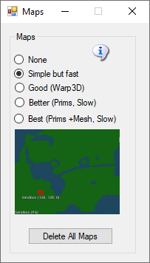

* **None**: No maps will be made. This is a good setting as the regions boot very quickly. Any existing maps are not deleted.
* **Simple but Fast**: MapImageModule is used with just Land showing
* **Good**: Uses Warp3D module with just Land showing
* **Better**: Uses Warp3D module with Land, Prims, and land Textures showing
* **Best**: Uses Warp3D module with Land, Prims, Mesh, Sculpts, and all Textures including prims showing.
* **Delete All Maps**: If you delete a region, the map will remain. Click this to clear out all maps. You will need to regenerate all maps again by choosing a setting and restarting all regions.

# Manual regeneration

Normally, one would generate maptiles at startup. You can also manually force maptile regeneration with the console command ‘generate map’.

# Permissions

Grid god mode allows certain users to take and control permissions over objects. Setting Grid God Mode on allows you to control individual users by editing their access level in the Wifi Users Panel. Any user with a level > 100 will be a grid god. You can set any estate owner or estate manager to be a grid god, too. Users can become Gods by using the Request Admin Level button in the Advanced Viewer menu.

God mode is a useful function. However, making copies of items that are no copy or no transfer and giving them to others could be illegal. Please remember that copyright laws for your country need to be respected.

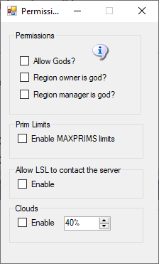

**Allow Gods:** God mode is available to selected people if enabled. These levels can be set for individual users in the Web control panel.

* Level = 0 is a normal user
* Level = 50 (or a level you set) is used to indicate a privileged user (e.g. who can set up new Hypergrid linked regions)
* Level = 100 is a God level user
* Level >= 200 become a Wifi-level user

**Region Owner is God:** If enabled, the region owner may go into God mode.

**Region Manager is God:** If enabled, any region estate manager may go into God mode.

**Prim Limits:**

Opensimulator normally does not enforce limits on the number of prims for a region or a parcel. The viewer can show a maximum of 45,000 prims.

**Beware: If you set this checkbox on, any prims over a count of 45,000 will be returned.**

You can lower or raise any region limit in the Regions Control panel.

Default: Unchecked

**LSL:**

**Allow LSL to contact the Server:** By default, OpenSimulator does not allow scripts to make HTTP calls to addresses on the simulator's LAN. This stop LSL from scanning your ports inside your firewall. If you need to allow scripts to make some LAN calls, enable this checkbox and edit Robust.HG.ini to set which IP addresses you want to expose to Opensimulator users. I recommend that you do not enable this unless you are very sure about what you're doing. When disabled, it will allow access only to port 8001 (Diagnostics port) on the server itself which is safe.

You can see more in Opensim.proto - search for OutboundDisallowForUserScripts.

Default: Unchecked

**Clouds**: The original particle clouds from the early days of Second Life are still available for older viewers such as Singularity.

Default: Checked

# Physics Engine

The Physics selection box lets you set very basic physics, where the only collidable object is a box shape. It supports the original Open Dynamic Engine physics. The ubODE engine, by Ubit Umarov, is an advanced version of ODE that is closer to Second Life compatibility with vehicles.  Bullet is an award-winning physics engine. Running Bullet in a separate thread is the default.

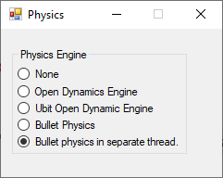

* None effectively does not model physics at all, making all objects phantom.
* OpenDynamicsEngine was the previous default physics engine in OpenSimulator 0.7.6.1 and before. It continues to provide a workable physics implementation. It does not currently support varregions.
* UBODE is closer to Second Life in vehicle performance.
* BulletSim and UBODE support varregions.
* BulletSim is the default physics engine. It provides the best performance and most functionality.
* When run in a separate thread, it cannot crash the Region if it dies.

## Physics Engine Links:

http://www.ode.org/

https://en.wikipedia.org/wiki/Bullet_(software)

# Port Settings and UPnP

Multiple TCP ad UDP Ports are used in Opensim. The defaults are shown below.

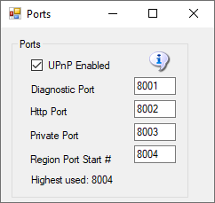

The defaults are 8001 (Diagnostic), 8002 (Public), 8003 (Private) and 8004 (Starting Region). If you have manually added more regions, their region ports also need to be open. Each region that is used takes up one port. They start at 8004 and count by one.

**Port Forwards:**

See the section on **Troubleshooting Ports** on how to manually enable the ports.

**UPnP Enabled:** The Outworldz program uses Universal Plug and Play (uPnP) to automatically allow data to come from the Internet to your computer. This is called "Port Forwarding". uPnP capability may be disabled in your router, or it may not support it.

If UPnP is enabled and your router supports it, Dreamgrid will automatically open the correct ports. This can be slow and time consuming, so you may prefer to disable UPnP and set your ports manually

Do you have Plug and Play (uPnP) issues? The Dreamgrid help menu has a useful tool to look at uPnP in your router:

UPnP (Universal Plug and Play) Tool for Windows

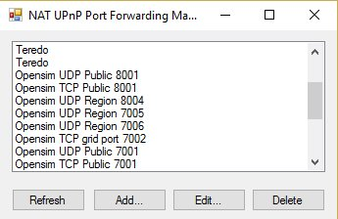

You can add, delete and modify the settings without a password, assuming you have uPnP enabled. This tool is available in Dreamworld and Dreamgrid in the Help menu.

# Troubleshooting Ports

A list of routers and instructions is at www.portforward.com which can help once you identify your router type.

Step 1) Get your PC LAN IP address by going to a DOS prompt and typing 'ipconfig'.



In the above photo, my IP was 192.168.1.3.   Yours is likely to be in the range 192.160.*.*, but it could also be a 10.0.*.* number. For my Linksys, it looks like this:



## IceCast/Shoutcast

Ports 8080 and 8081 must be added when you are running the Icecast/Shoutcast server.

## ****Which ports?****

You need to Port-Forward 8001, 8002, and 8004-8010 (or higher, I usually open up to 8050) to have room for expansion. You can also add 8080 and 8081 for Shoutcast/Icecast.  Don't do 8003 for security reasons. These can usually be done in ranges, like 8001-8002 and 8004-8010. The latter ones are for regions - you need one port per region, so this would let you have 7 regions. Add more if you want - nothing wrong with opening from 8020 to 8030 or so, or even to 8100.  In the above photo, I have opened ports 8004 through 8005.

They need to be open for both TCP and UDP. Your router will have a button or a pulldown to select UDP, TCP, or both.  If you don’t have a Both or All option, you must add them twice, once for UDP and once for TCP.

**How do I know this worked?** You can tell if it worked by starting Opensimulator, and then use a web browser to go to [http://www.canyouseeme.org](http://www.canyouseeme.org/), and enter 8002 while Opensimulator is running. Then click the Test Button at CanYouSeeMe. If that works, the ports are fine. If this does not work, try disabling your PC firewall. If this works, you must add exclusions to the firewall and then turn the firewall back on.

See **Firewall Issues** for help with the PC firewall.

Keep working with the router, firewall, antivirus exclusions and IP address until this test passes.

## Loopback:

The second part that must work is loopback - either your router supports it, or not. You can immediately tell if your loopback works after running the above CanYouSeeMe.org tests. You use your web browser to navigate to http://(YOUR PUBLIC IP):8002. Mine was http://24.173.0.66:8002. Of course, your IP address will be different than shown here, so use whatever CanYouSeeme.org shows you. If the system is working, you get a web page.

If not, you must add a loopback adapter. Go to <https://www.outworldz.com/Outworldz_installer/Loopback.htm> and follow the instructions.

Then go to Hypergrid/DNS Name page and enter your desired Hypergrid name

## Firewall Issues:

Windows will prompt you to allow Opensim to open ports when it first runs. If you say no, you will not be able to log in.

If you are using an Anti-virus with a firewall, such as ZoneAlarm, AVG Internet Suite, or anything else, running Start.exe may trigger the 3rd party firewall popup warnings. Opensim.exe needs to be allowed internet access, and Start.exe must be allowed to make changes to the firewall. If not, it will not work, and you will have to take manual action to fix it.

This code is safe and is digitally signed by me, Fred Beckhusen of Outworldz.com, and is open source and available for inspection at  <https://www.github.com/Outworldz>.

You may have to manually add firewall rules to allow incoming traffic on the ports.

1. On the client operating system, go to Start>Run and type firewall.cpl. The Windows Firewall window opens.  
2. Click on the “Advanced Settings” link on the left pane. The Windows Firewall with Advanced security window opens.  
3. Click on the “Inbound Rules” option.  
4. On the left pane, click on “New rule”.  
5. Under “Rule Type” select the option “Port” and click next.  
6. Select “TCP” and “specific local ports” options.  
7. Key in the port number, the port is 8001-8010 (or higher for more regions)  
8. Click Next.  
9. Select the option “Allow the connection”.  
10. Click Next, do not change any option here and click Next again.  
11. Specify a name for this rule.  
12. Click Finish.  
14. Repeat the above but using UDP from step 6

## More information about Opensim Ports

Here is more detail about ports and the way the interact with the outside world such as [www.canyouseeme.org](http://www.canyouiseeme.org/) and to my diagnostics tests.

Put simply, only port 8001 and 8002 can report back to those tools as to being open and can do so only when Opensim is running.

### ****Port 8001:****

8001 is a TCP/HTTP port that is open for help->Network diagnostics. It is unique to Dreamworld and not to Opensim. It is used for a "port forward" test, just like Canyouseeme.org does, and for a loopback test. It collects data on sim's going up and down to change the icons, and collects Partner information if two people click the partner prim.

### ****Port 8002:****

Opensim has a web server that web browsers understand, using the same protocol (TCP/HTTP) that tools like www.canyouseeme.org support. Put simply, Opensim is the only thing that listens to port 8002 and answers to http:// GET and POST requests on 8002. Port 8002 is like port 80, the default port for web pages. You can actually set Dreamworld's 8002 port to 80, and it will still work. You can then drop the need to type :8002 at the end of your hyperlink. http://hg.Osgrid.org does this. There would be no need to type the :80, as literally http:// means "add a :80 to the end of it".

8002 works with web-based ‘GET’ probe tools. If you do switch it to 80, then you forfeit using an additional web server on your home machine as only one program can listen to a port.

If Opensim is not running and your ports are open, it is as if you tried to connect to www.google.com's web server, but their web server is down. Nothing will happen, though your packets can get through the Google firewall because it is still open to traffic and is steering it to a dead server. You will get no answer. Similarly, if Opensim is not running, there is no web server to answer the request.

### ****Port 8003:****

This port is used by Opensim to listen to region traffic. Regions chat to the server database for login, presence, and other services use it to talk to the region so people can teleport from one region to another. In DreamWorld, regions must be on the same machine. In DreamGrid, just like OsGrid or any other remotely attachable grid, the regions can run on any machine anywhere in the world.

If you opened port 8003 to anyone on the web, you expose the internal database protocol to the web. Anyone with the right knowledge could attach a region to your sim. If you run a DreamGrid and host regions outside your LAN, it is recommended you use firewall rules to only allow access from known IP addresses running approved regions.

### ****Port 8004 and upwards:****

The region ports (8004-upward) run both TCP and UDP.   UDP is used for the viewer. UDP cuts the load on the server dramatically as there is no need to automatically always ACK every packet. As one example, no one cares if an audio stream gets briefly interrupted as you cannot hear it anyway, and it is too late to use it if it comes later in a retry. It just gets discarded.

For multiple regions in a single DOS box, all regions listen for TCP traffic on the last port used in that DOS box. As one example, if one region is in a DOS box by itself, and it is the first region, then it listens on both TCP and UDP on 8004.

If you had two regions in one DOS box, and they start at 8004, then the regions listen to UDP on 8004 and 8005, and both regions listen to 8005 for TCP traffic. You can check that the region is reachable on the Hypergrid only by using port 8005. 8004 will not respond, as it only listens to 8004 on UDP.

As a result, you can test regions with tools like Canyouseeme.org or a web browser

## Links:

Port Testing: http://www.canyouseeme.org

Loopback: https://www.outworldz.com/Outworldz_installer/Loopback.htm

Manual Trouble shooting:

https://www.outworldz.com/Outworldz_installer/Manual_TroubleShooting.htm

## Publish Grid

Publish Grid sends shows your grid in the list at [Hyperica.com](http://hyperica.com/).

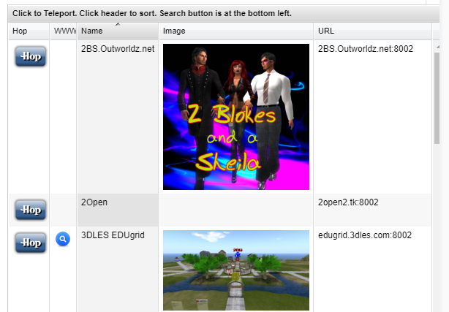

### Photos:

Click the Green box to load PNG image and it will appear in your listing.

### Publish Items Marked for Search:

Setting this switch will store any prims or regions you set for "Show In Search" into a database at Outworldz that shows the data in any Outworldz grid in your viewer in Search.

# Region Panel

Give your region a name and click [Save]. You can immediately start it up by clicking the name in the Regions panel. If you click Delete, the region INI file will still be there, but the file name will change to .bak from .ini.

Regions are stored in the folder Outworldzfile\opensim\bin\Regions in folders by each DOS box name. The DOS box folder has a Region folder in it that holds the Region.ini file. See Rules for INI files at the bottom of this Help file for more details.

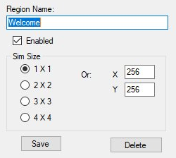

## Tips for regions:

* Always use a square sim size.
* Use multiples of 256 such as 256X256, 512X512, and so on.
* You can only set regions of the same size next to each other.
* Each region size can be anything from 256 X 256 to 1024 X 1024, or higher. Huge region sizes such as 4096 X 4096 can be used for flying or car racing. If you go over 8192 X 8192, you can expect it to be slow as the land size gets very, very large and laggy, as it grows exponentially.
* You can replace 4 single regions with a single 2X2 region and there will be no lag when crossing the (nonexistent) border. Vehicles can move smoothly anywhere. Also, NPCs can move about freely. Look in any region settings panel and you will see a "size" box. Check the 2X2 box, save it, and restart the region. It will grow North and East and will be 4 times larger overall. You will also need to move it in X and/or Y or delete the other regions as regions cannot overlap. You can shrink them, too, but objects that fall off the right and top edge will be lost.

## Region Options

The next section contains optional items you may choose to change.

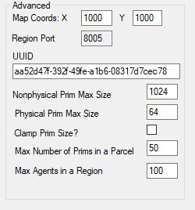

**Map Coords**: The (x, y) location of the region on the grid. You can set regions next to each other by changing the X and Y coordinates and restarting the region. The X and Y is the lower left point on the global map.

If you get messages saying that regions overlap, change the coordinates to some large number and retry the region boot. If your region still will not start due to it overlapping, type this into the Robust console:

deregister region id <UUID Goes Here>

Copy and paste the region UUID where it says <UUID Goes Here>. This can be done on Windows with Ctrl-V, or by right clicking the Robust title bar and selecting Edit->Paste.

**UUID**: Never change the UUID unless you want to start with a blank region again. Altering the UUID will force the system to create a new, blank region the next time it is started, and you will be forced to move your region to another spot.

**MaxAgents**: The maximum number of agents that can be in the in the region at any given time. The default is 100.

**MaxPrims**: The maximum number of prims that the region will be listed as supporting. However, this limit is not currently enforced by OpenSimulator. Due to LL protocol constraints, the maximum limit that can be shown is 45000.

**PhysicalPrimMax**: The maximum dimensions of a physical prim. This is a single number which applies to X, Y and Z co-ordinates. This will affect resizing of existing prims. Default is 10.

**NonphysicalPrimMax**: The maximum dimensions for a non-physical prim. This is a single number which applies to X, Y and Z co-ordinates. This will affect resizing of existing prims. Default is 256.

**ClampPrimSize**: If true then if a viewer attempts to create a prim which has any dimension larger than the NonphysicalPrimMax, then that dimension is reduced to NonphysicalPrimMax. Default is false;

**MaptileStaticUUID**: UUID of texture to use as a maptile for this region. Only set if you have disabled dynamic generation of the map tile from the region contents.

## Overrides

The next section are overrides for global settings made elsewhere.

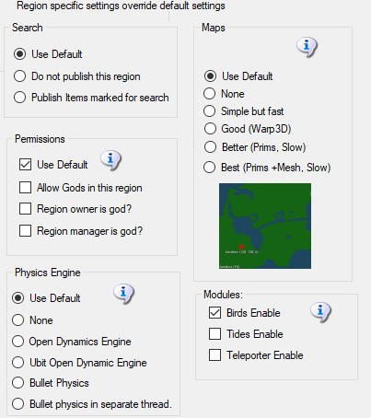

Each of these settings is specific to this ONE region. As an example, if you want maps to made Best quality for just one region, you can set it here. It will override the glob al maps setting for this region.

At lower right are settings to enable Bird, Tides, and Teleporter. These settings extend the Global settings to enable these modules on a per-region basis.

## Rules for INI files

Dreamgrid has several simple rules for *.INI files that differ slightly from stock Opensim.

* The INI file name must match the [Region Name] inside it. This example region [Region Name] must be saved as “Region Name.ini”.
* Only one [Region Name] is allowed in an INI file.
* All contents of a Region file are made by Dreamgrid and will be overwritten. See the Region Control Panel to change the settings.

## File Folder Layout

Dreamgrid uses a slightly different folder setting than stock Opensim. You cannot just copy them over in a file explorer unless you make a special pattern of folders, with an extra set of folders inside it.

The format is:

Opensim\bin\Regions\DOS Box Name\Region\RegionName.ini

Dreamgrid has several simple rules for *.INI files that differ slightly from stock Opensim.

* The INI file name must match the [Region Name] inside it. This example region [Region Name] must be saved as “Region Name.ini”.
* Only one [Region Name] is allowed in an INI file.
* All contents of a Region file are made by Dreamgrid and will be overwritten. See the Region Control Panel to change the settings.

# Region Edit Panel

This panel lets you edit or add new regions.

There are four sections: Region Name, Advanced, and Region Specific. Each section is covered below



## Region Name Section

Give your region a name:



Choose a sim size. Each section is 256 X 256 meters in size.

* 1X2 = 256 X 256 (Second life type)
* 2X2 = 512 X 512
* 3X3 = 768 X 768
* 4X4 = 1024 X 1024

You can type in a different size, such as 2048 X 2048 (8X8). Please be aware that very large sims can lead to poor performance, extensive RAM use, viewer crashes and inability to edit the land.

Click when done. You can immediately start the new region by clicking the name in the Region (Ctrl-R) panel.



Delete: Clicking Delete will remove the region. The region INI file will still be there, but the file be renamed to .bak and will not show again. If you want to rename the file back to INI, it will be recoverable. The file is in this folder:

Outworldzfiles\Opensim\bin\Regions\(DOS BOX NAME)\Region

## Advanced Section

This section at lower left has optional settings for each region.



## Map Coords:

The (x, y) location of the region on the grid on the Global Map. Range is from 0,0 to 65536,65536. If you set your regions around 1000,100, they will be centered on the Web Map. Adding a new region automatically places it 4 to the right of the furthest to the right.

## Region Port:

Read-only. This is displayed for information purposes only. All region ports start at the setting found in Settings->Network Ports in the box “Region Port Start #” and automatically count by one.

## UUID:

The unique ID of the region. UUID’s are randomly assigned at the very first region startup. To wipe out a region, change a few digits and restart. It will be blank. Change the numbers back and it will re-appear with the original content.

## Nonphysical Prim Max Size:

The maximum dimensions for a non-physical prim. This is a single number which applies to X, Y and Z co-ordinates. This will affect resizing of existing prims. Default is 256.

## Physical Prim Max Size:

The maximum dimensions of a physical prim. This is a single number which applies to X, Y and Z co-ordinates. This will affect resizing of existing prims. Default is 25.

## Clamp Prim Size:

If true then if a viewer attempts to create a prim which has any dimension larger than the Nonphysical Prim Max, then that dimension is reduced to Nonphysical Prim Max. Default is false

## Max Number of Prims in a Parcel:

Sets how many prims can be in a parcel (not a region, in later versions of Opensim, this will change to be regions). The maximum that can be shown in a viewer is 45,000. This limit is not enforced by Opensim unless you also check the Prim Limits checkbox in Settings->Permissions.

***Caution: Checking this box and rebooting may return prims!***

### Max Agents in a Region:

The maximum number a estate manager can set for how many people and NPCs can be in a region. Must be set in the viewer to be enforced.

## Region Specific Section

This section overrides defaults set elsewhere.



### Publish Items Marked for Search:



The default is set in Settings->Publicity. This setting overrides that setting for one region.

Setting this switch will Send data about any prims or regions you set for "Show In Search" into a database at Outworldz that shows the data in your viewer in Search. If you disable this, prims marked for Search and the regions marked for Show in Search will not be shown.

### Permissions:

The default is set in Settings->Permissions. This setting overrides that setting for one region.



#### Allow Gods:

God mode is available to selected people if enabled. These levels can be set for individual users in the Web control panel.

Level = 0 is a normal user

Level = 50 (or a level you set) is used to indicate a privileged user (e.g. who can set up new Hypergrid linked regions)

Level = 100 is a Wifi admin account user

Level = 200 can become a God is the first God setting is checked in the Permissions panel

### Physics Engine:

The default is set in Settings->Permissions. This setting overrides that setting for one region.



#### None:

None effectively does not model physics at all, making all objects phantom.

#### OpenDynamicsEngine

OpenDynamicsEngine was the previous default physics engine in OpenSimulator 0.7.6.1 and before. It continues to provide a workable physics implementation. It does not currently support varregions.

#### UBODE

UBODE is closer to Second Life in vehicle performance.

Notes:

* BulletSim and UBODE support varregions.
* BulletSim is the default physics engine. It provides the best performance and most functionality.
* When run in a separate thread, BulletSim cannot crash the Region if physics dies.

#### Maps:

The default is set in Settings->Maps. This setting overrides that setting for one region.



* **None**: No maps will be made. This is a good setting as the regions will boot very quickly. Any existing maps are not deleted.
* **Simple but Fast**: MapImageModule is used with just Land showing
* **Good**: Uses Warp3D module with just Land showing
* **Better**: Uses Warp3D module with Land, Prims, and land Textures showing
* **Best**: Uses Warp3D module with Land, Prims, Mesh, Sculpts, and all Textures including prims showing.

### Modules:

These settings enable features for this region and also require the feature be set in the Settings Panel. Unlike the other settings here, these must also be set here to enable them.



### Bird Module:

The bird module makes flocks of birds possible.

You must also enable the Bird Module in Settings->Birds.

There are many settings for the Bird Module. You can use the defaults. You must also click Enable on each region and reboot the grid. If this is checked the birds will automatically fly. If unchecked they will be available but must be started manually.

See Settings->Birds for more information.

### Tides Enable:

The tide module makes water go up and down. It has a buoy with a script to make boats and objects float with the changing water level

Individual region Tide setting must be enabled to make the water go up and down in each region.

See Settings->Tides for more information.

### Teleporter Enable

If the Teleporter Enable checkbox is set, the system will add the region to the build-in Teleporter and teleporter HUD. You can load these into your inventory with the Load Local OAR option.

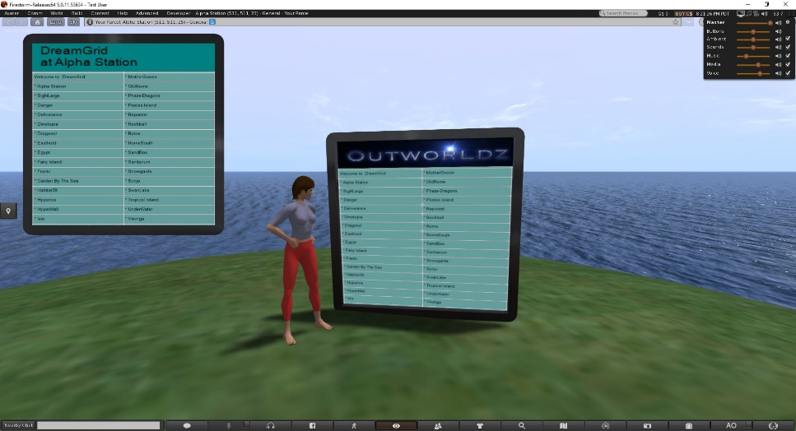

# Region Files

Open the Region Panel with Ctrl-R, or go to SettingsRegion.

There will be anywhere from one to many Region.INI files in your system. These show up in this panel. The default is an island called "Welcome".

**Sorting:** Click any column to sort



# Refresh button

Click Refresh to rescan the system status and update this panel.

# Add Regions

Click the Add button to make a new region. You only need to give it a name and save it.

# View menu

There are four views selectable by the View button at upper left

**List View:** The List view can be sorted by Name, Group, Agents or Status by clicking the column name.

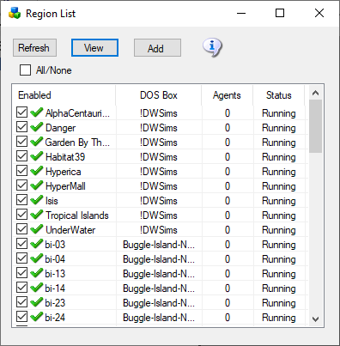

**Icon View:** The second view is a small icon-only view for larger grids

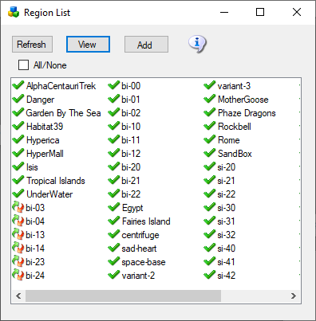

**Map view**: The third view only appears if Maps are enabled before the system boots. It has zoomable map images by the scroll wheel.

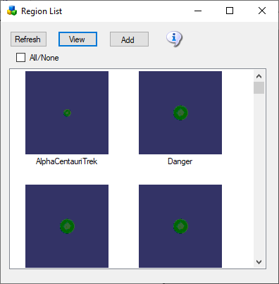

# Moving Region Files from Older systems

**(Note: Currently Disabled)** You may move old region.ini files from other Opensim systems into Dreamgrid using a special drag and drop mechanism.

Use the windows explorer and navigate to the original Dreamworld location on your disk. Look in Opensim\bin\Regions for any region INI files.

Left click each region, one at a time, and drag and drop it onto the Regions panel.

This message will appear:

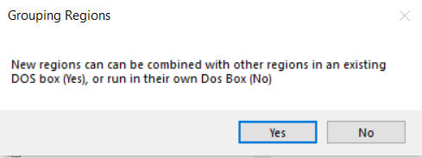

**Yes:** If you answer Yes, a Chooser dialog will appear. You must choose which region you want to combine your new region with. This will place both regions into a single DOS box. When you first start out, your only choice will be Welcome, as you only had one region. If you want a new box, select No.

**No:** If you answer No, you will get a different DOS box when this region starts.

You should limit the number of DOS boxes by combining your regions into logical groups.   A typical system will run 4 to 8 such groups.  You can run more, but you will pay a penalty in RAM use for each box.

# Regions

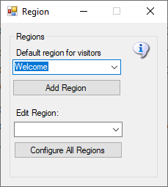

**Default region for visitors:** Hypergrid visitors get sent to the Default region for visitors.

**Add a Region:** will bring up a dialog form for adding a new region.

**Edit Region:** will bring up a dialog form to edit the selected region.

**Configure All Regions:** will open all regions for editing.

# Auto Restart and Startup Settings

Opensim uses up more and more RAM as people arrive and leave. Periodic restarting of regions is necessary to clear memory. You can set up a restart timer here.

Dreamgrid will not restart a region if avatars are present. It will restart the region only after all avatars leave.

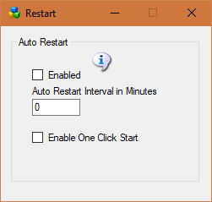

**Enable:** If enabled, the auto restart interval will be set to 1440 minutes, which is one day. If disabled, the regions will try to run forever.

**Auto restart Interval:** The number of minutes a region runs before it restarts.

* 0 = Off
* 720 is 1/2 day. 1440 is one day. 2880 is 2 days.
* If Autobackup is enabled, this interval will be extended beyond the Autobackup Interval by 30 minutes to allow Autobackup to complete.

**Enable One Click Start**: If set, running Start.exe will automatically start Opensim without needing to click the second [Start] button.

# Tides Module

The tide module makes water go up and down. It has a buoy with a script to make boats and objects float with the changing water level. It must be used on a single sim surrounded by water.

Tides is by Jak Daniels from <https://github.com/JakDaniels/OpenSimTide>

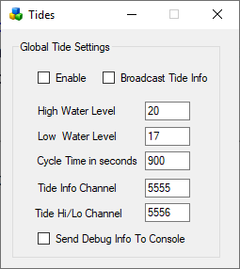

**Enable**: If set, Tides are enabled globally. Individual region Tide setting must be enabled to make the water go up and down in each region.

**Broadcast Tide Info**: This must be checked to send tide level info to the provided buoy. It uses channel 5555.

**High Water Level**: default 20 meters

**Low Water Level**: default 17 meters

**Cycle time in seconds**. default 900 seconds = 15 minutes

**Tide Info Channel**: As the tides rise and fall, a tide level command is broacast on this channel. This must be set to 5555 for the provided script to work.

**Tide High Low Channel**: An annoucement wil be made on this channel when the tide is at a high or low level.

**Send Debug Info to console:** will send chat to the regions console for debugging.

Buoy:

A floating buoy is provided in the Load Local IAR menu.

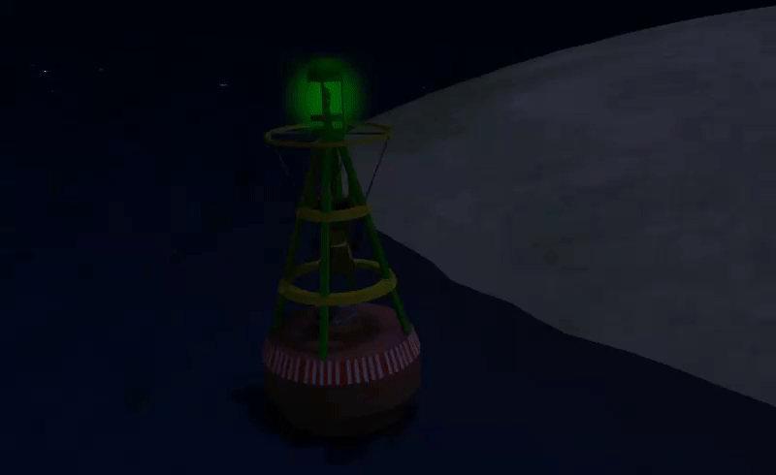

**Tide script:**

To make items float on water just place this script into their root prim.

integer listen_handle;  
vector myPos;  
float tideLevel = 20.0;

default {  
 on_rez(integer start_param)  
 {  
 llResetScript();  
 }

state_entry()  
 {  
 listen_handle = llListen(5556, "TIDE", NULL_KEY, "");  
 }

listen( integer channel, string name, key id, string message )  
 {  
 tideLevel=(float)message;  
 myPos = llGetPos();  
 llSetPos(<myPos.x, myPos.y, tideLevel + 0.05>);  
 }   
}

More complex stuff can be done using the full info channel, which has data about where in the tide cycle we are. Rez a cube prim and place this script inside:

integer listen_handle;  
default  
{  
 state_entry()  
 {  
 listen_handle = llListen(5555, "TIDE", NULL_KEY, "");  
 }

listen( integer channel, string name, key id, string message )  
 {  
 llWhisper(0,channel + " " + name + " " + id + "\n" + message);  
 }  
}

The cube will whisper info about the current tide position every time the tide is updated.

Links:

https://github.com/JakDaniels/OpenSimTide

# Vivox Voice

Vivox powers voice for millions of players in many of the world's best games.

You must first ask for a free Opensim Vivox account by clicking the link. These accounts are free for non-commercial use. It can take a week to get a response, so please be patient and polite.

When you get the email, add your User ID and Password to this form and enable it. Restart the system and voice should work.

Links:

https://support.vivox

http://www.hypergridbusiness.com/2011/12/free-vivox-for-all

# License Agreement:

Dreamgrid is Copyright 2011 by Outworldz, LLC under the GNU Affero General Public License (AGPL 3.0). The GNU Affero General Public License is a free, copyleft license for software and other kinds of works, specifically designed to ensure cooperation with the community in the case of network server software. All rights are irrevocable provided the stated conditions are met. This License explicitly affirms your unlimited permission to run the unmodified Program. <https://www.gnu.org/licenses/agpl-3.0.txt>

Source code: https://github.com/Outworldz/DreamWorld

Other open source licenses apply to Opensimulator and the libraries and other functions included herein. A list is provided in several folders:

* \Licenses_to_Content
* \Opensim\ThirdPartyLicenses
* \Opensim\NOTES

**Data Collection Policy**

Outworldz, LLC does not collect personally identifiable information. No personal details of your site, such as user names or passwords, are other details are sent to Outworldz.

**Publicity:**

If you check the **Publish Grid** button, the system will send public information about your grid, such as the web address, to Outworldz, LLC for use in the Hyperica.com directory. This information is removed automatically if you turn your grid off or uncheck the box. This data only appears when your system is online.

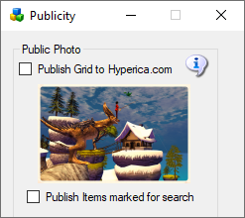

if you check the **Publish Items Marked for Search** button, details about any regions marked for search or items marked for search are collected by a web crawler and indexed in a database so other people can locate them. if you do not want these items exposed to others to find, please do not check the box.

**DNS**

The DYN DNS system stores public IP addresses and your domain name as is necessary to run the DNS system.

**Anonymous data**

The unique random identifier of your machine is stored at Outworldz along with a small amount of anonymous data. This includes whether your software passes diagnostics, it's revision level, and whether it is on the Hypergrid. This is used for quality control purposes.

The Outworldz web server may also automatically collect and store routine information in server logs. This may include details of how you used our service, such as your search queries or Internet protocol address, browser type, browser language, the date and time of your request and referral URL.